***Abstract***

# VOICE INTEGRATED USER INTERFACE FOR GEOSPATIAL MAP BASED WEB-APPLICATIONS

# Aryan Bamane1, Atharva Khamkar2, Abhishek Patil3, Hrituja Desai4

*1Computer Science & engineering,*

*D Y Patil Technical Campus Talsande, India, aryanbamane2 @gmail.com*

*2 Computer Science & engineering,*

*D Y Patil Technical Campus Talsande, India, khamkaratharva08@gmail.com*

*3 Computer Science & engineering,*

*D Y Patil Technical Campus Talsande, India, patilabhi2944@gmail.com*

*4 Computer Science & engineering,*

*D Y Patil Technical Campus Talsande, India, hrutujadesai@gmail.com*

***This research explores the integration of voice assistants in geospatial web platforms, aiming to enhance human–computer interaction through natural language commands. We introduce a voice-enabled interface within the BStreams platform, employing tools such as the Web Speech API, Leaflet, and Mapbox geocoding to enable dynamic geospatial data visualization. A structured, mixed-methods approach guided the study, beginning with the identification of commonly used geospatial commands through a survey of 66 participants. These results were compared with language model predictions from ChatGPT, revealing a strong correlation (r = 0.81, p < 0.01) between model-suggested terms and user-reported terminology. Building upon this, we developed a specialized geospatial discourse framework and implemented a working prototype to validate its effectiveness. Usability testing confirmed the system's potential for intuitive map interaction via voice, though challenges remain in domain-specific language interpretation. Additionally, the study highlights the significance of user profiles and contextual language understanding in designing accessible and efficient voice user interfaces for GIS applications. All data and the open-source codebase are provided to support future research and development in this domain.***

***Keywords:***

***NLP, voiceGIS, geovoice, offlinespeech, LeafletVoice, OpenLayersVoice, mapinteraction, ondevicevoice, GPUVUI, NLPGIS, webGIS****.*

**1. INTRODUCTION**

The project titled “A Voice-Enabled User Interface for Geospatial Map-Based Web Applications” addresses a significant gap in the current state of geographic information systems (GIS) and how users interact with them. While GIS technology is widely adopted, especially for tasks related to geographical data and mapping, it often relies on complex user interfaces that can be difficult for some users to navigate. Historically, user-computer interactions evolved with the introduction of graphical user interfaces (GUIs), which made technology more accessible to the general public. The Apple Macintosh in the 1980s played a crucial role in this shift, and GIS systems quickly integrated GUIs for their ability to display maps and data visually. However, despite the early adoption of these interfaces, GIS systems remain intricate, and the user experience can still be overwhelming for many. As a result, there's been a long-standing interest in exploring alternative ways to interact with GIS systems, such as voice control, to make them more user-friendly and intuitive. Although there has been progress in this area, voice-controlled GIS interfaces are still not commonly used in practice, which is a gap this project aims to address.

**1.1 VOICE AND GIS CONVERGENCE**

Voice-enabled user interfaces (VUIs) are revolutionizing how users interact with technology, offering an intuitive, hands-free approach for controlling digital systems. This project focuses on the development of a lightweight, scalable VUI specifically designed for geospatial map-based web applications. The goal is to enhance map interaction by allowing users to issue natural language voice commands that are interpreted and executed in real time. While many existing solutions rely heavily on cloud-based APIs, this system explores the possibility of on-device voice recognition using GPU/NPU acceleration to ensure minimal latency and increased privacy. The application leverages open-source GIS libraries such as Leaflet and OpenLayers to perform common geospatial actions like zooming, panning, and toggling layers. This not only improves accessibility for non-technical users but also addresses the challenges of making GIS tools more responsive, adaptive, and user-centric.

**1.2 RESEARCH CONTEXT AND CHALLENGES**

Voice-enabled user interfaces (VUIs) are revolutionizing how people interact with technology by allowing them to control systems with natural language commands. This approach has proven to be intuitive and efficient, as it eliminates the need for physical input devices like keyboards or mice. The goal of this project is to develop a VUI specifically designed for geospatial web applications, which will enable users to interact with maps using simple voice commands. For example, users could say commands like "zoom in," "find a location," or "show traffic," and the system would execute these actions on the map in real-time.

A key aspect of this project is to focus on performance and privacy. Many existing voice control systems rely on cloud-based services, meaning that the user's voice data is sent to remote servers for processing. This raises concerns about data security and privacy, particularly when dealing with sensitive location data. To address this, the proposed system will use on-device voice recognition, which means that all processing happens directly on the user's device. This not only improves performance by reducing latency (the delay in processing the commands) but also ensures greater privacy since no voice data is transmitted to external servers. To facilitate map interactions, the system will use popular open-source GIS libraries such as Leaflet and OpenLayers, which allow users to perform common tasks like zooming, panning, and toggling map layers.

This development aims to make GIS tools more accessible, particularly for non-technical users, while also improving responsiveness and adaptability to meet the needs of a wide range of users. Ultimately, the goal is to make geographic data and mapping tools more user-friendly, especially for individuals who may find traditional interfaces challenging.

**2. PROBLEM DEFINITION AND SCOPE**

Recent studies, including those by Mahmoudi et al. (2023) and Blanco et al. (2023), highlight the growing importance of integrating voice-enabled interfaces into spatial platforms. Building on these findings, our project takes a step further by creating a real-time prototype of a voice-controlled GIS system that is designed specifically for Hindi- and English-speaking users. The project aims to test the system with domain-specific voice commands (e.g., "show the nearest hospital" or "zoom out to view the entire city") and gather feedback from users to refine the system's accuracy and functionality.

**2.1 PROBLEM STATEMENT**

The objective of this project is to develop a voice-enabled web application that allows users to interact with geospatial maps using natural language commands. This system will improve the accessibility and usability of GIS tools, making it easier for users, regardless of their technical background, to work with geographic data and maps. By allowing voice-based control, the application will simplify the process of interacting with complex GIS systems, offering a more intuitive and user-friendly alternative to traditional input methods.

**2.2 SCOPE**

* Real-time voice commands for zoom, pan, query
* Integration with mapping APIs
* NLP for command recognition
* Accessible interface for diverse user groups

**3. METHODOLOGY AND IMPLEMENTATION**

The project "A Voice Enabled User Interface geospatial map-based webapplications" consists of several interconnected modules, each responsible for a specific functionality. Below is an overview of the key modules and their roles in the system:

1. User Interface Module :

Provides an intuitive and responsive design for users to interact with the application. Displays maps and visualizations of geospatial data. Accepts user input via voice commands and touch gestures. Shows real-time feedback and notifications based on user actions.

2. Voice Command Processing Module:

Captures and processes user voice commands using a speech recognition engine. Converts voice input into text for further processing. Handles command interpretation to execute corresponding actions (e.g., zooming, panning, or querying the map).

3. Geospatial Data Management Module:

Manages the retrieval and storage of geospatial data from various sources (e.g., GIS data providers, APIs). Processes and formats incoming data for use within the application. Provides functionalities for querying, filtering, and updating geospatial datasets.

4. Testing and Debugging Module:

Provides tools for testing the application at various stages of development. o Supports unit testing, integration testing, and user acceptance testing (UAT). o Aids in debugging issues and improving the overall reliability of the application.

**3.1 SYSTEM ARCHITECTURE**

The system consists of four modules:

1. UI Module – built using Leaflet.js
2. Voice Recognition – powered by TensorFlow.js and Web Speech API
3. Geospatial Data Manager – handles GeoJSON
4. Backend API – Node.js for processing.

Following is the Designed Architecture of the system:

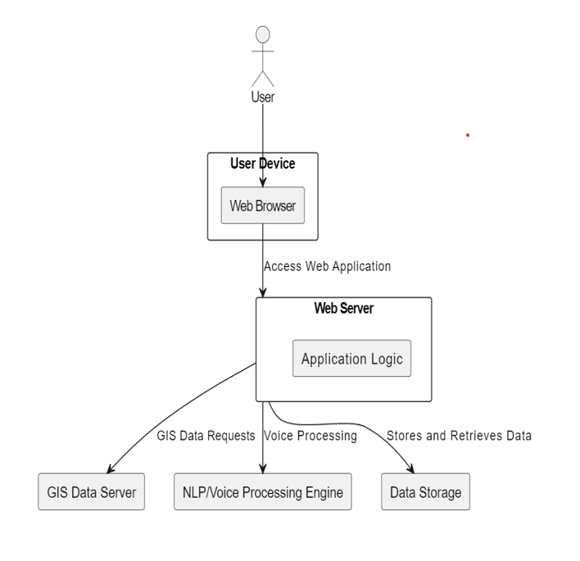

Fig.-1. Working of voice based map app

**3.2 Usability Testing**

10 participants tested the system using real voice queries. Tasks included location search, zoom control, and layer switching. Results showed high satisfaction, though some complexity remained in command variation handling.

Following is the image that represents basic implementation and usability testing:

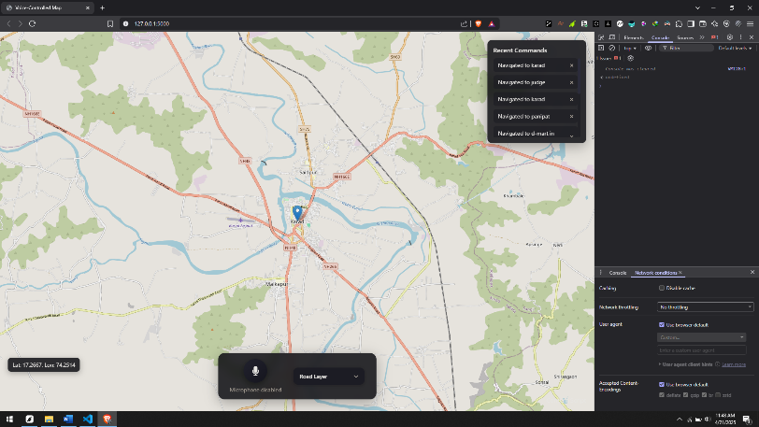

Fig.-2. Running voice-based map app

**4. TECHNOLOGY USED**

The successful development of a voice-enabled geospatial map-based web application relies on integrating various cutting-edge technologies to ensure functionality, performance, and a seamless user experience. The following key technologies are utilized in this project:

**4.1 Voice Recognition Technology**

To enable voice control, the project leverages advanced **on-device voice recognition** systems that process voice commands locally, ensuring faster response times and enhanced privacy.

**4.2 Geospatial Libraries and Frameworks**

For map visualization and geospatial analysis, the project utilizes well-established open-source GIS libraries:

* **Leaflet**: A lightweight JavaScript library that provides interactive maps. Leaflet allows for smooth map interactions like zooming, panning, and adding different layers (e.g., satellite imagery, terrain data, etc.). It supports a wide range of plugins, making it ideal for enhancing the map's features and capabilities.
* **OpenLayers**: Another powerful open-source mapping library that is highly extensible. OpenLayers is used for more complex mapping tasks, such as displaying vector layers, performing spatial analysis, and integrating various map tiles.

**4.3 Web Technologies**

To ensure that the voice-controlled GIS system is accessible and responsive on all platforms, the application is developed using modern web technologies:

* **HTML5** and **CSS3**: These are used to structure and style the web application. HTML5 provides semantic markup, and CSS3 ensures the application is visually appealing and user-friendly across devices.
* **JavaScript**: The backbone of the application’s interactivity. It handles the logic for processing voice commands and mapping them to the corresponding actions on the map (such as zooming in/out, changing map layers, or searching for specific locations).
* **Web Speech API**: A JavaScript API used to integrate speech recognition directly into the web browser. This API enables real-time voice-to-text transcription, allowing users to interact with the system by speaking commands in natural language.

**5. CONCLUSION**

In conclusion, the **Voice-Enabled Geospatial Map-Based Web Application** represents a voice-based navigation approach to geospatial technology. By embracing voice interaction and modular design, the project not only addresses current challenges in GIS usability but also sets the stage for innovative solutions that can evolve with technological advancements and user needs. The successful implementation of this project has the potential to revolutionize the way users interact with geospatial information, making it more accessible, intuitive, and engaging for a diverse range of audiences.

1. **REFERENCES & BIBLIOGRAPHY**

[1] Gartner. 5 Trends Emerge in Gartner Hype Cycle for Emerging Technologies. 2018. Available online: https://www.gartner.com/ smarterwithgartner/5-trends-emerge-in-gartner-hype-cycle-for-emerging-technologies-2018 (accessed on 6 July 2022)

[2] Freepik-Flaticon. Gamer Icons. Flaticon. Available online: https://www.flaticon.com/free-icons/gamer (accessed on 30 December 2022)

[3] Freepik-Flaticon. Maps and Location Icons. Flaticon. Available online: https://www.flaticon.com/free-icons/maps-and-location (accessed on 30 December 2022).

[4] Hayat, S.; Rextin, A.; Bilal, A. Understanding the usability issues in contact management of illiterate and semi-literate users. PLoS ONE 2021, 16, e0259719. [CrossRef] [PubMed].

[5] Blanco, T.; Martín-Segura, S.; de Larrinzar, J.L.; Béjar, R.; Zarazaga-Soria, F.J. First Steps toward Voice User Interfaces for Web-Based Navigation of Geographic Information: A Spanish Terms Study. Appl. Sci. 2023, 13, 2083. [CrossRef]